K2002 Jeopardy内容

【Language Arts】

**10 points**

Can you read these words?

**pal, what, said**

**20 points**

How many characters are there in the story “Gus Takes the Train”?

**Three. Gus, Peg, the conductor**

**30 points**

Can you speak out a noun, a verb, an adjective?

**Noun: people, animals, things, places;**

**Verb: hop, play, jog, hit…**

**Adjective: round, curved, big, small, red, yellow, one, two… (Adjectives to describe shape, size, color, number)**

**40 points**

Can you match the picture with the word? **Plant shop Fire house Bakery Garage Pet shop Library**

 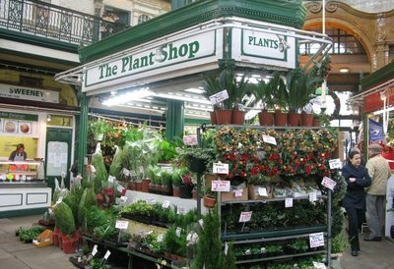 

**A B C**

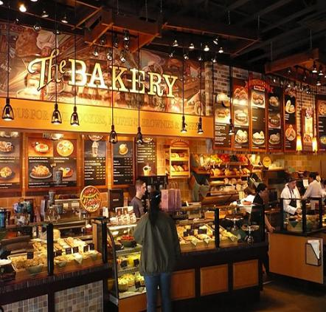 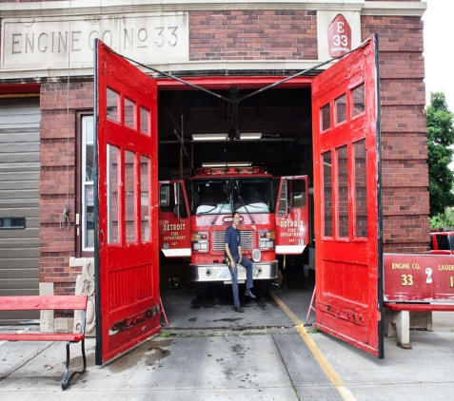 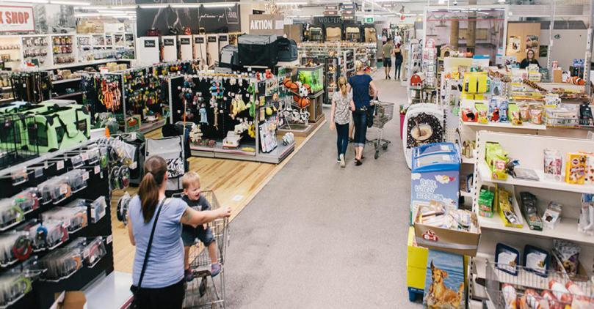

**D E F**

**Plant shop B Fire house E Bakery D Garage A Pet shop F Library C**

【Math】

**10 points**

What’s this sign? ＜

**It‘s a less than sign.**

**20 points**

Can you read these number sentences?

7 - 1 = ? 7+1=?

**One fewer than seven is six.**

**One more than seven is eight. (Seven plus one equals eight. Seven and one is eight. )**

**30 points**

Can you read this sentence? 10+3>10

**Ten and three is greater than ten.**

**40 points**

Can you read these number sentence?

**?+3=5 8+?=18.**

**What number and three is five? What number plus three equals five?**

**Eight and what number is eighteen? Eight plus what number is eighteen?**

【Science】

**10 points**

What’s this?

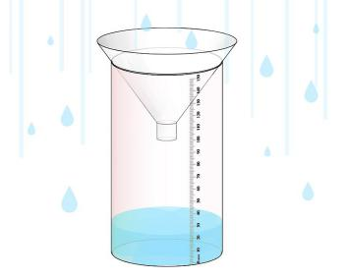

**It’s a rain gauge.**

**20 points**

How many states of matter? What are they?

**Three. Solid, liquid, Gas.**

**30 points**

Could you tell me something about wolves?

Are gray wolves only gray?

**one wolf, two wolves**

**（1）What are wolves? Wolves are wild dogs. They are bigger than dog.**

**(2)live: Wolves live in a den. Wolves live in packs. One pack has a pack leader. Wolves live in forests, tundra and on prairies.**

**(3)Food: deer, moose, elk, caribou， rabbits, beavers.**

**(4)Wolves have good hearings and good sense of smelling.**

**(5)Are wolves dangerous? Wolves almost never hurt people.**

**(6)Cubs chase small animals.**

**(7) Red Wolf和Gray Wolf，区别是**

**Red Wolf is nocturnal. Red Wolf has large ears.**

**Gray Wolf hunt during the daytime. Gray Wolf不只是gray一种颜色，还有brown, white, black, and reddish浅红色。**

**40 points**

**Measuring Cup Ruler Tape Measure Balance Thermometer**

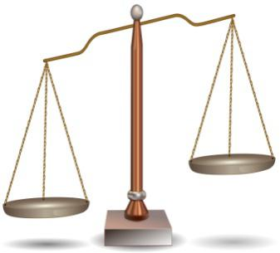 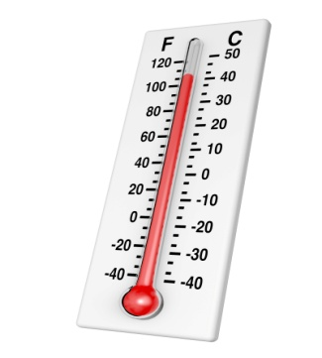 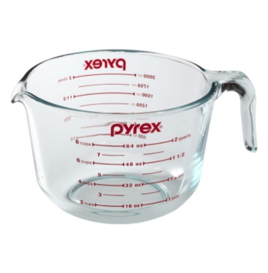

**Balance Thermometer Measuring Cup**

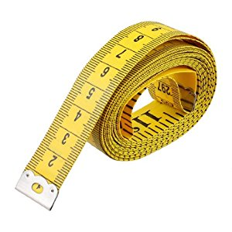 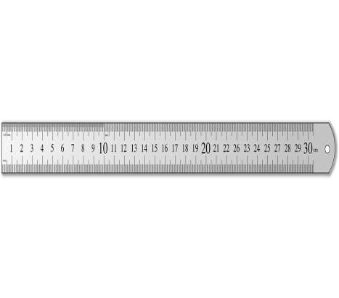

**D Ruler**

**Measuring Cup C ruler E Tape Measure D Balance A Thermometer B**

【Reading】

**10 points**

**Can you read these sentences?**

Sid Pig did it!

Sid can have his fig.

Sid bit his big fat fig.

**20 points**

**Can you read these sentences?**

Hi, I am Lucia.

Does the librarian help me?

Yes!

We sit and look at my book.

I like the library.

**30 points**

**Can you read these sentences?**

Gus has to run to get the train.

He has a big bag to pull.

Run, Gus, run!

Gus cannot pull up his bag.

The conductor can help him.

The train is full.

Gus can see many kids.

**40 points**

**Can you read this book?**

Once upon a time, Jack sat on a big hill.

Jack had every sheep with him.

“It is not fun to sit,” said Jack.

“I will yell **Wolf** for fun!”

His friends ran up the hill to help.

They did not see Wolf.